Follow us at




  As the appliance brand that's hotter, cooler, faster and better than the rest, one might say that the Thermador of today is most certainly not your grandfather's Thermador. |  | The innovation behind our appliances is Apple-crowd worthy, our cooking performance and BTU capability has been hitting the gym, and our sleek, modern designs would translate nicely to any fashion runway of the world. The new, bold Thermador is flat-out "sweet" - pretty much the opposite lingo of what your grandfather might say. |  | Or perhaps your grandfather would say that?  In reality, the notion of your grandfather is changing as well. Recently, we were featured in an Ad Age story focusing on brands successfully marketing to baby boomers. Read More



More News
 |  | WE'RE LOOKING FOR BFFs  Thermador's social media platforms are more robust than ever. Be sure to "Like" us on Facebook, where you'll stay up to date on all of our food-related posts and other Thermador news. Visit our blog that's chock full of recipes, guest food-blogger posts, appliance tips and industry news. And if you engage us in a Twitter conversation, it could make your day even brighter. We love to chat, and we're always looking for new best friends forever!
    OUR KITCHEN IS GETTING STEAMY  Last month Thermador announced its partnership with rock star food blogger Jaden Hair of Steamy Kitchen, widely considered one of the most influential food bloggers in the country.  Read More |  |   TWO PEAS' THERMADOR KITCHEN FEATURED  Thermador's other all-star blogger, Maria Lichty of Two Peas and Their Pod, was recently featured in an influential online publication. Lichty recently completed a complete kitchen remodel and included Thermador appliances.  Read More

KITCHEN TRENDS

INDUCTION VS. GAS: WHICH IS BEST?
Induction cooking is perhaps the most revolutionary advancement in cooking technology the last 30 years. And it's also one of the most foreign technologies to American home cooks. So what is induction cooking? And how is induction different or better than cooking with gas?
Unlike gas cooking, induction uses a magnetic field generated by an alternating electric current to efficiently produce heat directly on the cookware, rather than heat from the gas flames to the cookware.
Read More

Product Spotlight
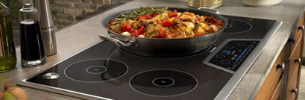  MASTERPIECE® INDUCTION COOKTOP  Catch a glimpse of our state-of-the-art induction cooktops, which incorporate the largest heating element in the industry, as well as our patented Thermador Sensor Dome® and PowerBoost™ technology.  Read More |  | 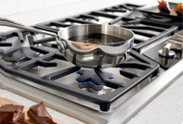  MASTERPIECE® GAS COOKTOP  Learn more about our gas cooktops that are known for their power and precision with the patented ExtraLow® feature, perfect for simmering sauces.  Read More

Recipes of the Month
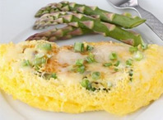  ASPARAGUS OMELET  Two Peas and Their Pod crafted a special recipe just for us, which can be created to perfection with the use of the ExtraLow® feature on Thermador's burners.  Read More |  | 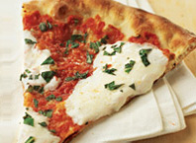  PIZZA MARGHERITA  Incorporating the colors of the Italian flag, this recipe originated in Naples by Chef Raffaele Esposito, who crafted it for Queen Margherita di Savoia.  Read More |  | 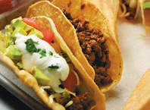  BEEF TACOS  The first documented taco dates back to 1520, when Bernal Diaz del Castillo created a recipe. The key to this simple recipe is including plenty of toppings.  Read More



Follow us at

http://app.streamsend.com/private/UavY/hJB/fDn1VBc/unsubscribe/13953287
BSH Home Appliance Corporation, 5551 McFadden Avenue Huntington Beach, CA 92649
©2011 Thermador

